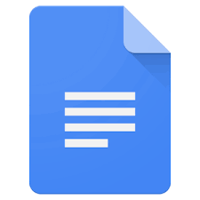 

**Photos for Class**  <http://www.photosforclass.com/>

**Kids Search**   <http://www.kidzsearch.com/>

**Typing Club**  <https://www.typingclub.com/>

**Google Earth**  <https://www.google.com/earth/>

**Newsela**  <https://newsela.com/>

**Library services** (Tumblebooks, MultCo Library)

<http://www.pps.net/library-services>

**Padlet**  <https://padlet.com/>

**PBS kids**  <http://pbskids.org/>

**Dual Immersion Spanish Resources**

[**http://www.engagingeverystudent.com/dual-immersion-spanish-resources/**](http://www.engagingeverystudent.com/dual-immersion-spanish-resources/)

**Docs**  <https://www.google.com/docs/about/>

**Google Drive**  <https://www.google.com/drive/>

**Myon for Student Log In**

<https://clever.com/oauth/instant-login?client_id=e9883f835c1c58894763&district_id=55ba7ce893d0390100000aed>

**Lexia for Student Log In (clever link)**

<https://clever.com/oauth/instant-login?client_id=afea41fda08c929f7c8e&district_id=55ba7ce893d0390100000aed>

TechSmart Links

<https://spark.adobe.com/>

Raz Kids <https://www.raz-kids.com/>